**Q1. Consider table Stud(Roll, Att,Status) Write a PL/SQL block for following requirement and handle the exceptions. Roll no. of student will be entered by user. Attendance of roll no. entered by user will be checked in Stud table. If attendance is less than 75% then display the message “Term not granted” and set the status in stud table as “D”. Otherwise display message “Term granted” and set the status in stud table as “ND”**

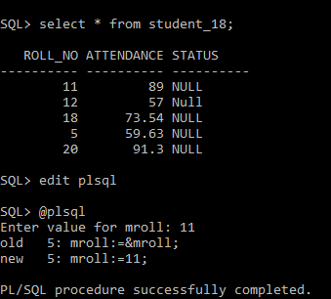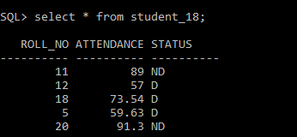

**PL/SQL CODE:-**

Declare

mroll number(10);

matt number(10);

Begin

mroll:=&mroll;

select attendance into matt from student_18 where roll_no=mroll;

if matt<75then

dbms_output.put_line(mroll||'Term Not Granted');

update student_18 set status='D'where roll_no=mroll;

else

dbms_output.put_line(mroll||'Term Granted');

update student_18 set status='ND'where roll_no=mroll;

end if;

End;

/

**2. Write a PL/SQL block for following requirement using user defined exception handling. The account_master table records the current balance for an account, which is updated whenever, any deposits or withdrawals takes place. If the withdrawal attempted is more than the current balance held in the account. The user defined exception is raised, displaying an appropriate message. Write a PL/SQL block for above requirement using 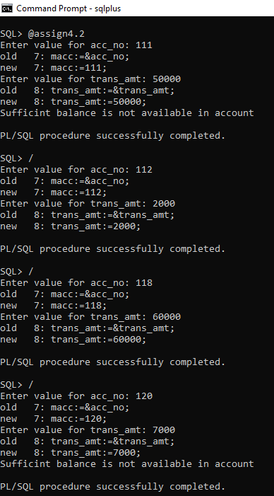user defined exception handling**

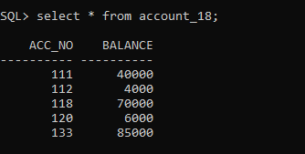

**AFTER PL/SQL PROCEDURE:-**

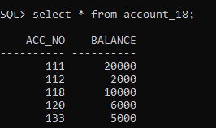

**PL/SQL CODE:-**

Declare

mbal number(10);

macc number(8);

trans_amt number(10);

No_sufficient_bal exception;

Begin

macc:=&acc_no;

trans_amt:=&trans_amt;

select balance into mbal from account_18

where acc_no = macc;

if (trans_amt<=mbal) then

update account_18 set balance=(balance-trans_amt)

where acc_no=macc;

else

raise No_sufficient_bal;

end if;

Exception

When No_sufficient_bal then

Dbms_output.put_line('Sufficint balance is not available in account');

End;

/

**3. 1. Borrower(Roll_no, Name, Date_of_Issue, Name_of_Book, Status) 2. Fine(Roll_no, Date, Amt) Accept Roll_no & Name of Book from user. Check the number of days (from date of issue), if days are between 15 to 30 then fine amount will be Rs 5per day. If no. of days>30, fine will be Rs 50 per day & for days less than 30, Rs. 5 per day. After submitting the book, status will change from I to R. If condition of fine is true, then details will be stored into fine table.**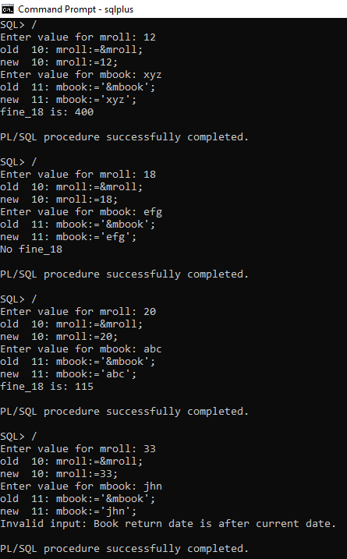

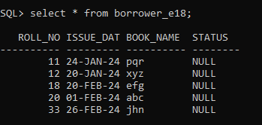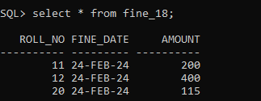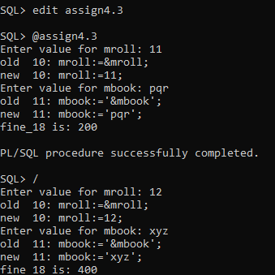

**PL/SQL CODE:-**

Declarel

mroll number(5);

mbook varchar(10);

mdate date;

mfine_18 number(10);

datediff number(10);

-- User-define_18d exceptions

invalid_input EXCEPTION;

Begin

mroll:=&mroll;

mbook:='&mbook';

select issue_date into mdate from borrower_e18 where roll_no=mroll and book_name=mbook;

datediff:=to_date(sysdate)-to_date(mdate);

-- Check for overdue

IF datediff < 0 THEN

RAISE invalid_input; -- Negative date difference indicates invalid input

end if;

IF datediff < 15 then

dbms_output.put_line('No fine_18');

update borrower_e18 set status='NF' where roll_no=mroll and book_name=mbook;

ELSIF datediff > 15 and datediff < 30 then

mfine_18:=(datediff*5);

dbms_output.put_line('fine_18 is: '||mfine_18);

update borrower_e18 set status='F' where roll_no=mroll and book_name=mbook;

insert into fine_18 values(mroll,sysdate,mfine_18);

ELSIF datediff > 30 then

mfine_18:=((datediff-30)*50+(30*5));

dbms_output.put_line('fine_18 is: '||mfine_18);

update borrower_e18 set status='F' where roll_no=mroll and book_name=mbook;

insert into fine_18 values(mroll,sysdate,mfine_18);

End if;

Exception

WHEN invalid_input THEN

dbms_output.put_line('Invalid input: Book return date is after current date.');

End;

/